Civil war in Georgia

UNSC Resolution: | 1255
Date of adoption: | 07/30/99
Operative paragraph: | 2
Demand number: | 1255.0211

David Siroky

Wording of demand

widen and deepen commitment to the UN-led peace process, continue to expand dialogue and contacts at all levels and display without delay the necessary will to achieve substantial results on the key issues of negotiations.

List of addressees of the demand

Government of Georgia, Abkhazia

Short-term compliance

Description of the addressee(s)’ conduct

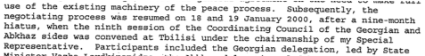

S/2000/39

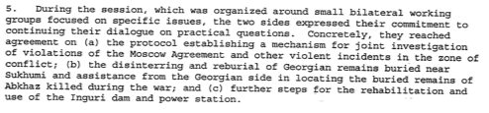

S/2000/39

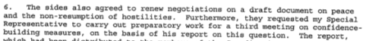

S/2000/39

Assessment

Short-term compliance
No or marginal compliance (1) | Medium low compliance (2) | Medium high compliance (3) | Full or almost full compliance (4)

Considerations underlying the assessment

Medium-term compliance

Description of the addressee(s)’ conduct

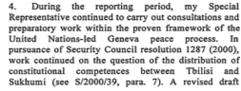

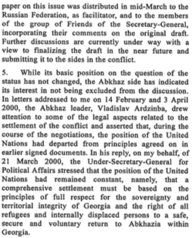

S/2000/345

Assessment

Medium-term compliance
No or marginal compliance (1) | Medium low compliance (2) | Medium high compliance (3) | Full or almost full compliance (4)

Considerations underlying the assessment

Depth of demand

Assessment

Level of depth of demand
Low depth of demand (1) | Medium depth of demand (2) | High depth of demand (3)

Considerations underlying the assessment

Level of confidence about coding decisions

Level of confidence about coding decision
Extremely high | High | Moderate

Comments to IPI (if any)

Civil war in Georgia

UNSC Resolution: | 1255
Date of adoption: | 07/30/99
Operative paragraph: | 5
Demand number: | 1255.0511

David Siroky

Wording of demand

achieve an early and comprehensive political settlement, which includes a settlement on the political status of Abkhazia within the State of Georgia, which fully respects the sovereignty and territorial integrity of Georgia within its internationally recognized borders

List of addressees of the demand

Government of Georgia, Abkhazia

Short-term compliance

Description of the addressee(s)’ conduct

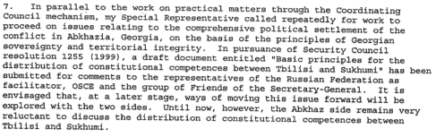

S/2001/1008

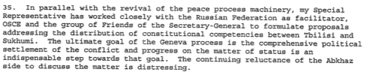

S/2000/39

Assessment

Short-term compliance
No or marginal compliance (1) | Medium low compliance (2) | Medium high compliance (3) | Full or almost full compliance (4)

Considerations underlying the assessment

Medium-term compliance

Description of the addressee(s)’ conduct

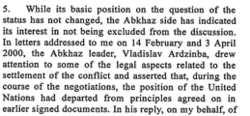

S/2000/345

S/2000/345

Assessment

Medium-term compliance
No or marginal compliance (1) | Medium low compliance (2) | Medium high compliance (3) | Full or almost full compliance (4)

Considerations underlying the assessment

Depth of demand

Assessment

Level of depth of demand
Low depth of demand (1) | Medium depth of demand (2) | High depth of demand (3)

Considerations underlying the assessment

Level of confidence about coding decisions

Level of confidence about coding decision
Extremely high | High | Moderate

Comments to IPI (if any)

Civil war in Georgia

UNSC Resolution: | 1255
Date of adoption: | 07/30/99
Operative paragraph: | 7
Demand number: | 1255.0711

David Siroky

Wording of demand

address the issue of refugees and displaced persons, in particular those resulting from the hostilities of May 1998, and the demographic changes resulting from the conflict as well as their imprescriptible right to return to their homes in secure conditions urgently by agreeing and implementing effective measures to guarantee the security of those who exercise their unconditional right to return

List of addressees of the demand

Government of Georgia, Abkhazia

Short-term compliance

Description of the addressee(s)’ conduct

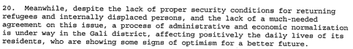

S/2000/39

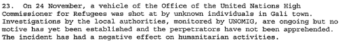

S/2000/39

Assessment

Short-term compliance
No or marginal compliance (1) | Medium low compliance (2) | Medium high compliance (3) | Full or almost full compliance (4)

Considerations underlying the assessment

Medium-term compliance

Description of the addressee(s)’ conduct

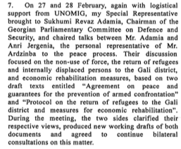

S/2000/345

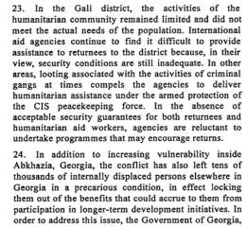

S/2000/345

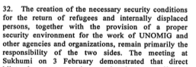
S/2000/345

Assessment

Medium-term compliance
No or marginal compliance (1) | Medium low compliance (2) | Medium high compliance (3) | Full or almost full compliance (4)

Considerations underlying the assessment

Depth of demand

Assessment

Level of depth of demand
Low depth of demand (1) | Medium depth of demand (2) | High depth of demand (3)

Considerations underlying the assessment

Level of confidence about coding decisions

Level of confidence about coding decision
Extremely high | High | Moderate

Comments to IPI (if any)

Civil war in Georgia

UNSC Resolution: | 1255
Date of adoption: | 07/30/99
Operative paragraph: | 9
Demand number: | 1255.0911

David Siroky

Wording of demand

enhance efforts to implement the decisions of 16-18 October 1998 and 7-9 June 1999 aimed at building confidence, improving security and developing cooperation, in an effective and comprehensive manner, notably at the prospective meeting in Yalta

List of addressees of the demand

Government of Georgia, Abkhazia

Short-term compliance

Description of the addressee(s)’ conduct

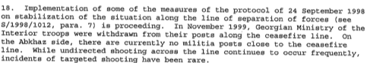

S/2000/39

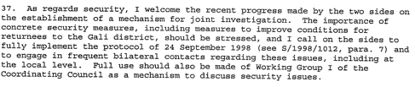

S/2000/39

Assessment

Short-term compliance
No or marginal compliance (1) | Medium low compliance (2) | Medium high compliance (3) | Full or almost full compliance (4)

Considerations underlying the assessment

Medium-term compliance

Description of the addressee(s)’ conduct
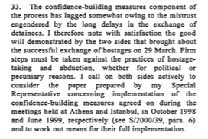

S/2000/345

Assessment

Medium-term compliance
No or marginal compliance (1) | Medium low compliance (2) | Medium high compliance (3) | Full or almost full compliance (4)

Considerations underlying the assessment

Depth of demand

Assessment

Level of depth of demand
Low depth of demand (1) | Medium depth of demand (2) | High depth of demand (3)

Considerations underlying the assessment

Level of confidence about coding decisions

Level of confidence about coding decision
Extremely high | High | Moderate

Comments to IPI (if any)

Civil war in Georgia

UNSC Resolution: | 1255
Date of adoption: | 07/30/99
Operative paragraph: | 10
Demand number: | 1255.1011

David Siroky

Wording of demand

observe strictly the Moscow Agreement (S/1994/583 annex I)

List of addressees of the demand

Government of Georgia, Abkhazia

Short-term compliance

Description of the addressee(s)’ conduct

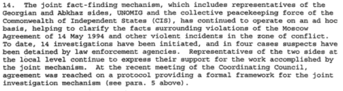

S/2000/39

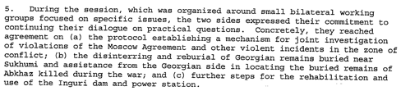

S/2000/39

Assessment

Short-term compliance
No or marginal compliance (1) | Medium low compliance (2) | Medium high compliance (3) | Full or almost full compliance (4)

Considerations underlying the assessment

Medium-term compliance

Description of the addressee(s)’ conduct

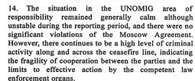

S/2000/345

Assessment

Medium-term compliance
No or marginal compliance (1) | Medium low compliance (2) | Medium high compliance (3) | Full or almost full compliance (4)

Considerations underlying the assessment

Depth of demand

Assessment

Level of depth of demand
Low depth of demand (1) | Medium depth of demand (2) | High depth of demand (3)

Considerations underlying the assessment

Level of confidence about coding decisions

Level of confidence about coding decision
Extremely high | High | Moderate

Comments to IPI (if any)

